Final Major Project- Short Film Evaluation:
‘Imperium’
Throughout this Final Major Project piece, there was a long process to get to our final product. However, throughout this process, there were many strengths and weaknesses to our work and how certain events and scheduling worked out for my group and I.
Pre-production Process
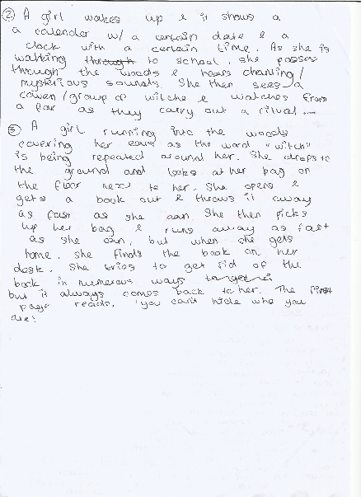
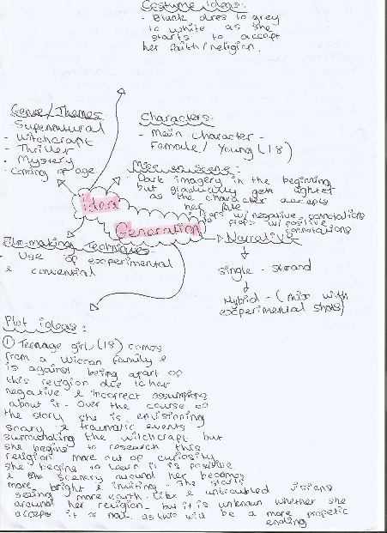
For example, this process started off with pre-production, in which we had one main issue; we struggled with idea generation.

After watching short films on YouTube from the previous year, our group decided that we aimed to create a short film that included supernatural/thriller themes, due to the fact that we believed that this would be the easiest type of film to create while still making it effective. However, we wanted to ensure that we didn’t want to make our piece too cliché with common horror codes and conventions. Therefore, we decided to base our film on witchcraft as a member in our group is a part of the Wiccan religion, so we thought this would be interesting to display more information around this religion and witchcraft in general. However, we wanted to have a different take on this as we wanted to portray this in a more positive light, rather than giving witches a negative portrayal.
Unfortunately, it took us a few days to come up with a set, structured storyline, as my group and I did not necessarily work well as a team during this time due to the fact that we all had different ideas and butt heads over it, however, in the end we decided on something, even if not every member in the group were completely happy with the decided storyline.
The obvious horror narrative structures that is included in our storyline was religious beliefs, death and murder, supernatural curses, etc. We also focussed on Todorov’s narrative theory by using equilibrium, in which we gave our character more authority and power as the storyline progressed. Disruption and attempt to repair the damages made was also included in our story. In a way we ensured that our protagonist also had antagonist qualities, as she goes from being good to bad, then good again. But this was a creative choice we made for our short film, as we did not want to just focus on the typical elements of a horror structure.
Because of what we wanted to portray in our work, all of our research was based on witchcraft and how they are portrayed in a negative light and how we wanted to stray away from this stereotype by showing that witches. However, I regret doing research this way, because it was hard to fully achieve a horror story if we were going to have a somewhat happy ending. What would have been easier and more effective, was if we just focussed more on witchcraft and the meaning behind it, another aspect of research that we should’ve concentrated on more was filmmaking, and how to make an effective short film. If we had rather focused on this, instead of gathering all the information on Wicca and witchcraft, we could’ve had more freedom in slightly changing the storyline to help it fit into our chosen genre.
A questionnaire was also created in order to help us discover more about our intended audience and whether not they would this type of short film intriguing, and the answers proved that they would.
The research portion of pre-production proved to be a strength and a weakness and we gathered all of the knowledge that we needed, but it also limited us as we could not make the changes we wanted to as our work would not be consistent with our research.
When it came to finishing our script and deciding on the characters that we wanted to use, we ensured that we used trained actors from the performing arts department in the college. However, after contacting the head of department and thinking that we had set actors, they never actually got back to us nearing the filming day, therefore, we had to come up with a back plan and find other actors. For example, a member in our group had a friend that is an actor, who agreed to play the main part. Additionally, we also used friends for other two characters, however the only problem with this was the fact that were not professional/trained actors, therefore their performance would not be on the same level of that of a professional. Therefore, for future projects, I aim to use professional actors, or if I am not able to achieve this, I will aim to have little to know dialogue within my short films.
Another aim we had was for our story to be set in the post-apocalyptic future, therefore, we wanted to ensure that our locations matched this aesthetic and time period. Firstly, an abandoned building was the main place we aimed to film in. However, the main weakness with this was gaining access to these places as with most of them did not have direct contacts, so we had to contact the council to ask if it would be okay to film. In the end, we found that it would be easier to use the onsite classroom availability at college, and just adjust the set to our liking to ensure that we could achieve the correct scenery. This was an overall weakness as it would’ve looked more effective if we had found a more aesthetically suiting place to film in. However, we still made it possible and worked with what we had.
Overall, the rest of pre-production went quite quickly and smoothly due to the fact that we had already been through this process before with prior projects, so we had all of the knowledge and skills to be able to pull this off quickly.

Production Process
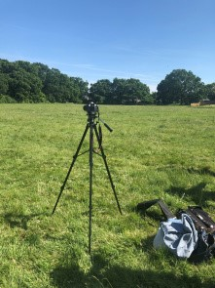
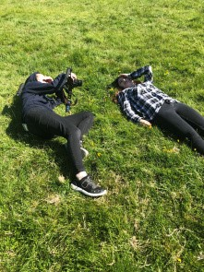
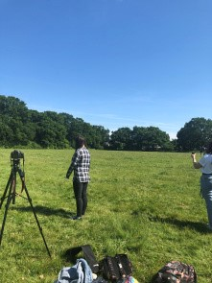
Firstly, it took us two days overall to complete filming, in which we had two filming locations. The first issue that came up however was the first day that we filmed at college. Due to some scheduling issues with our chosen actors, they could not make it to the location any earlier than 5:30pm. This meant that we had limited time to film as the college had to close shortly after that time. This proved be a serious weakness of the first production because it meant that we had to rush through filming as the college had to close at a certain time, meaning we had to leave earlier. Even though we had filmed everything that we wanted to, it was done as accurately as we wanted. Furthermore, we noticed that two characters that played the bullies, did not act as well as we wanted them to. Their acting seemed forced and fake which did not make our work seem as authentic as we wanted it too. Due to this experience, I have accepted that for future projects, that I should focus on using trained actors only if I want to create a piece like this.
Another issue was that the gender roles had changed from being two male characters when writing the script, to making them females, due to the fact that we could not get a hold of any male actors.
On the other hand, though, our main actress was very authentic with her acting and showed to be very effective, which relieved us as a group because we knew that she performed in the way we wanted her too.
However, another weakness was that when filming, the actors did not really stick to the script, although they still got the main idea across, it was still inconsistent with the previous pre-production work that we had produced, which was somewhat disappointing. Another issue that concerned me was that the fact that not every shot on the shot-list was portrayed, and I’m confident that if we did portray this, that our piece would’ve been longer as it is always better to get more footage than less.
The second filming day, however, went a lot better than the first as we actually used all of the camera angles we were aiming to, such as the Dutch/canted angle and the worm angle. Additionally, because we were filming outside, the footage looked clearer and more professional. The footage that we had recorded on the previous filming day looked grainy due to the fact that we were filming nearing the evening, the lighting outside kept changing, meaning the lighting on the camera kept adjusting/ changing which resulted in our footage not being as high quality as we wanted.
Furthermore, for the scene we were filming, there was little dialogue which showed an improvement in acting from the main actress. This shows that little dialogue is more effective when making short films. Anyhow, another strength of this filming day was that we managed our time effectively by not rushing as much as we did on the previous day. Personally, this is how I prefer to work, as this means it is easier to focus on the quality of the work that I am producing rather than just getting the work done quickly. Therefore, I aim to work like this in the future.
Editing Process
Bringing this film together through editing was an interesting process as I used old and new skills to aid me along with this edit. I ensured that my edit was similar to my fellow group members as I did not aim to create anything too different from them, which is why we kept checking each other’s edits throughout to ensure none of us had strayed away from the initial idea.
However, I did notice while editing that once compiling the whole sequence together, it was not as long as we intended for it to be. Our script was 7 pages long, meaning that our short film was supposed to be this long, however, the longest I could manage to make it was 5 minutes. This was an obvious weakness as we couldn’t tell all the story that we wanted to in full effect. However, by editing in a certain way, I left a lot of gaps in certain scenes, such as the dream sequence scene as the main character wakes up, this is when they worked well, and it actually made the film slightly longer.
However, a big aspect of the editing that I focussed on was sound. Ensuring that I had a layered soundtrack, I included a mixture of Foley, ambiance and music. Foley was the most important aspect for me, the reason being that, a lot of our own recorded Foley did not sound loud enough and did not have the effect I wanted it to. Therefore, I spent a large portion of time finding copyright free sound effects such as books falling, doors closing, ripping pages, gathering pages, bodies falling, etc. Even adding in the simplest sounds, made the biggest difference as it made the film seem more professional and realistic.
But to avoid having to do this in the future, I want to ensure that all sound is recorded by myself and more professionally, as it is always easier to do this yourself because you know what you want.
Non-diegetic sound such as music and certain sound effects was another element I found was effective, especially within the horror genre. The sounds of heartbeats and some parts of a scary music soundtrack was added. Creating a sense of suspension, it is a practical way of getting the genre across to the audience, without it being directly through the storyline.
Not only is sound important to edit, but so is ensuring that visual effects and the cinematography match our genre. For example, in the dream sequence, I had an idea to use a glitch effect, which is what I used during our Film School unit. I remembered how to do it so I did not need to use any YouTube tutorials this time. Using this effect created a sense of surrealism, this established a more eerie effect. This is essential in editing as it emphasizes your original footage even more as it makes the scene stand out amongst others, which is always important to consider when creating a short film. This shows how editing bring everything together.
Furthermore, when colour grading, I spread it out in 3 different areas in which I coloured the parts in different ways. In the beginning, I focussed on giving the scenes a blue tint, to signify the cold, lonely feeling of living in this post-apocalyptic world. I also focussed on trying to adjust the grainy footage by adjusting the brightness and contrast. But, in the end product I think that this was effective as it makes the audience feels uncomfortable due to the cold, unwelcoming tones.
In the mid-scenes, where she is using her powers, I used a purple tint and darkened the scenes as I find that purple often connotes magic or spells, and because this was the scene in which she was using her powers.
For the dream sequence scene, I focussed more on the warm, orange and yellow tones, while also adding a soft fade. The reason behind this being I wanted to make it obvious to the audience that she was having a dream/ was in a ‘dream world’, and I am confident that I achieved this.
The colour grading definitely pieced this project together and brought the themes to life. Colour grading is always something I ensure to do because it immediately improves the quality of the work.
Lastly, when creating a title sequence, I wanted to use a glitch effect again, but because I am not used to using AfterEffects. However, I used a YouTube tutorial to help me figure out to make a professional, glitch effect title sequence. Using this tutorial ensured that I did everything right and that I did not waste any time trying to create something I did not understand. Therefore, this is something I will always aim to do when I do not understand how to do something to save time.
Conclusion: The Finished Product
Overall, through the strengths and weaknesses throughout our work, I am happy with the finished product. This is due to the fact that there were no major changes to the original story, and it turned out the way that I thought it would. I found that we made the best out made situations, for example, having to find new actors. This turned out working in our favour and we tried our best to produce a piece of work that reached a high standard.
However, this does mean to say I would not make changes for future projects. For example, having better scheduling, research, actors, and ensuring that we are staying thoroughly true to the pre-production work. This will mean that I can produce a piece of work that is to the highest standard of my ability.
Peer Evaluation: After finished editing, we presented our work to a group and ten people, and this was their feedback.
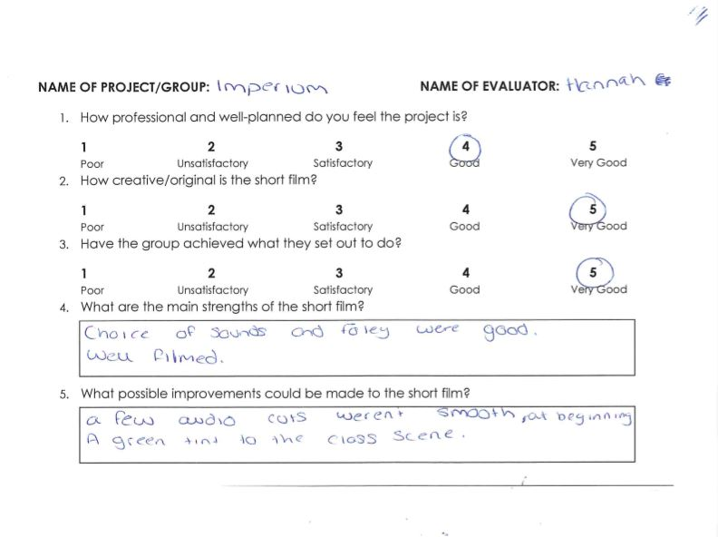

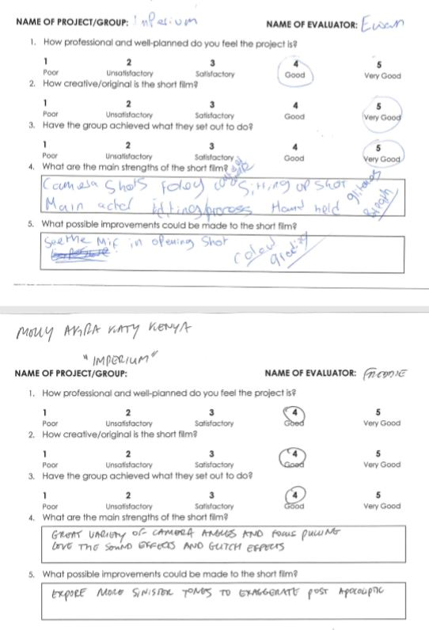
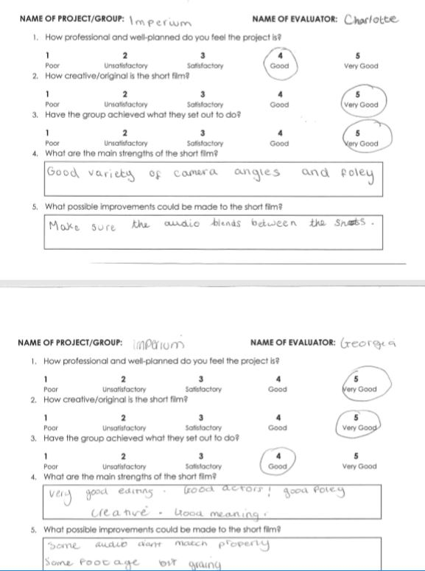

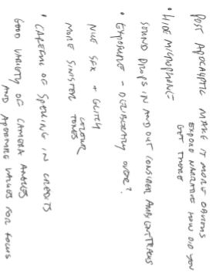

Self-Evaluation
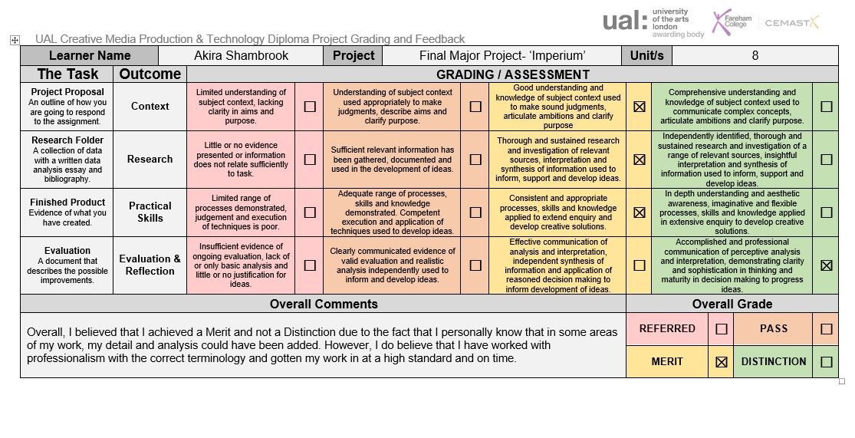
I completed a self-evaluation sheet to display my own opinions on what I think of my work and the grade I think I should achieve.

